
subproject plan
SYI700 System integration
University West

PLC System Design & Communication

Aanu Olakunle
Humble Otamiri

Date | Task |  | Examiner sign | Student sign
 | Approved description
28 /11/ 2025 | Implemented the OPC UA server to establish and test real-time communication between the PLC (TwinCAT 3) and other subsystems, ensuring reliable bidirectional data exchange.  Integrated ADS communication in TwinCAT 3 to enable real-time data exchange between the PLC, SCADA and Crane Robot .

Subtask description

- Description
This subtask involves developing, implementing, and testing the PLC program responsible for controlling the automated coffee preparation process. The work includes designing the control logic, configuring inputs and outputs, and ensuring the correct sequence of operations. The PLC logic will be developed, tested, and deployed on the hardware to ensure the correct operation of process sequences. Integration with SCADA, UR, Crane, and AGV systems will be carried out in collaboration with the individuals responsible for other subsystems.
- Figure

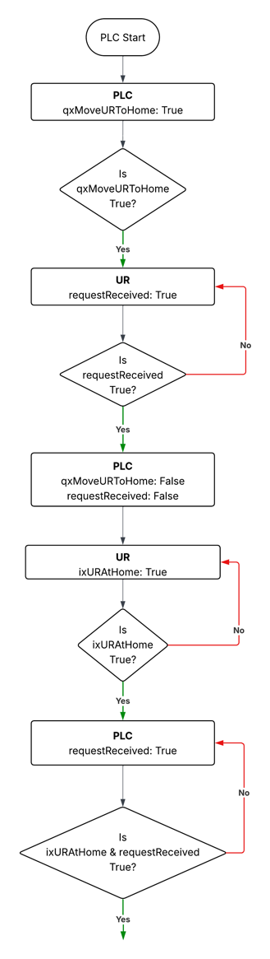

- Your black box description
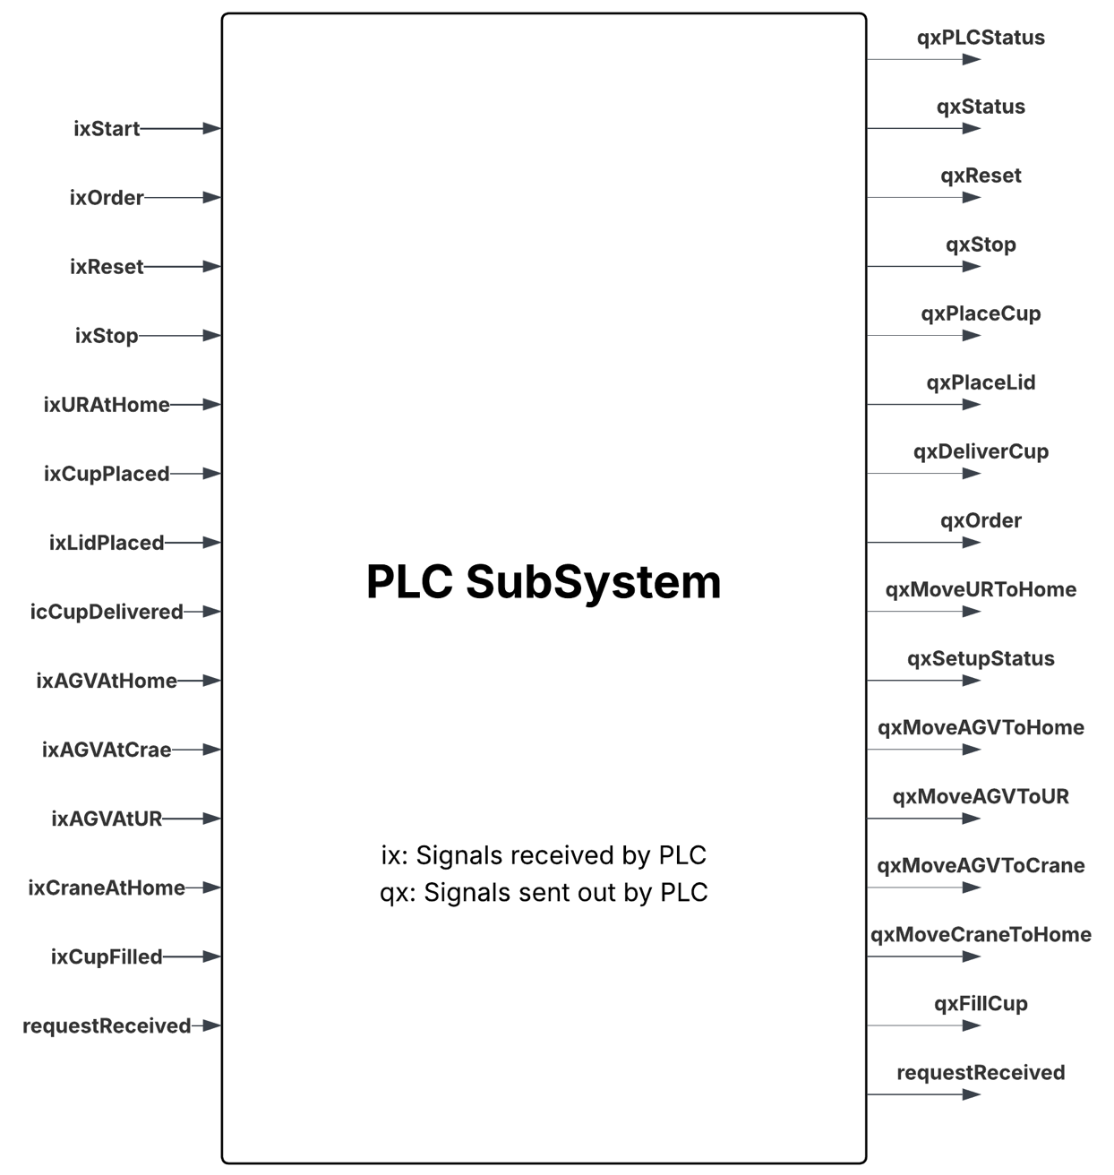
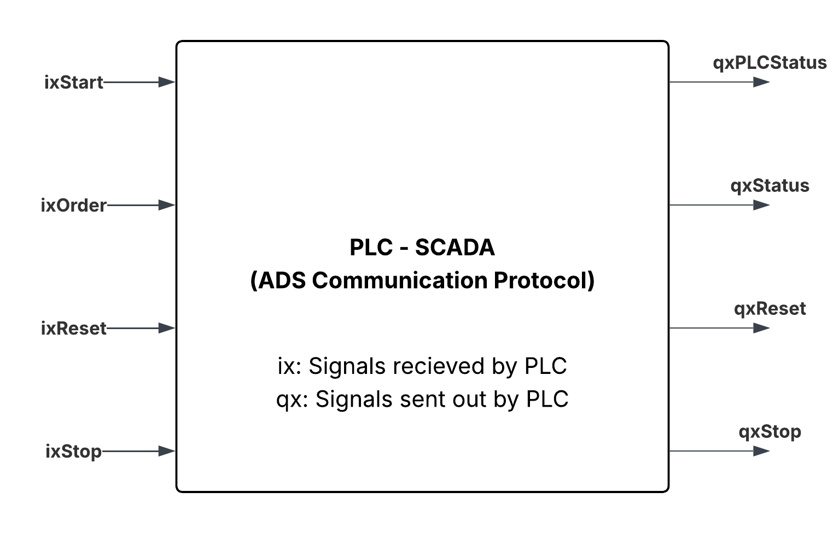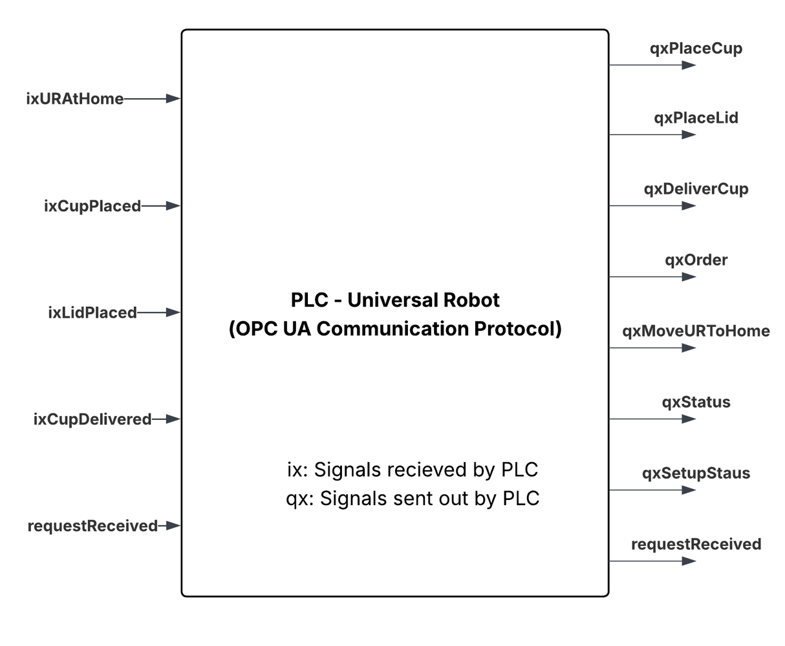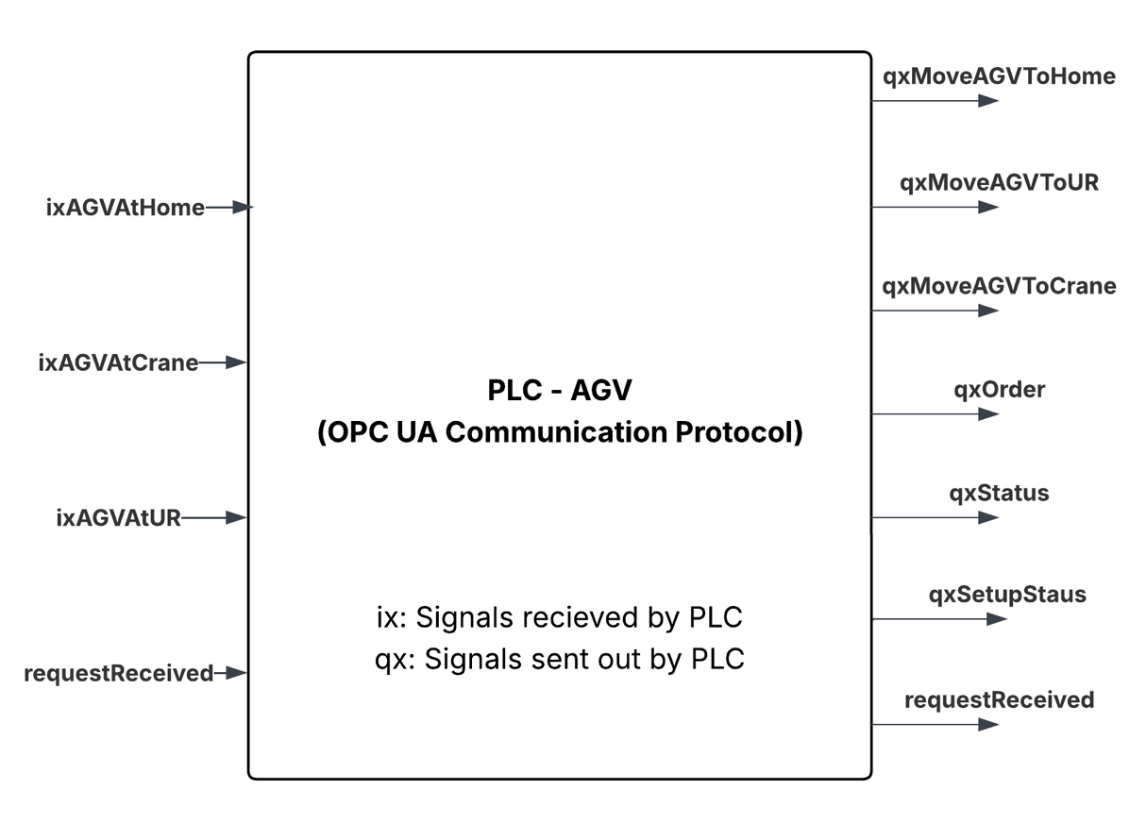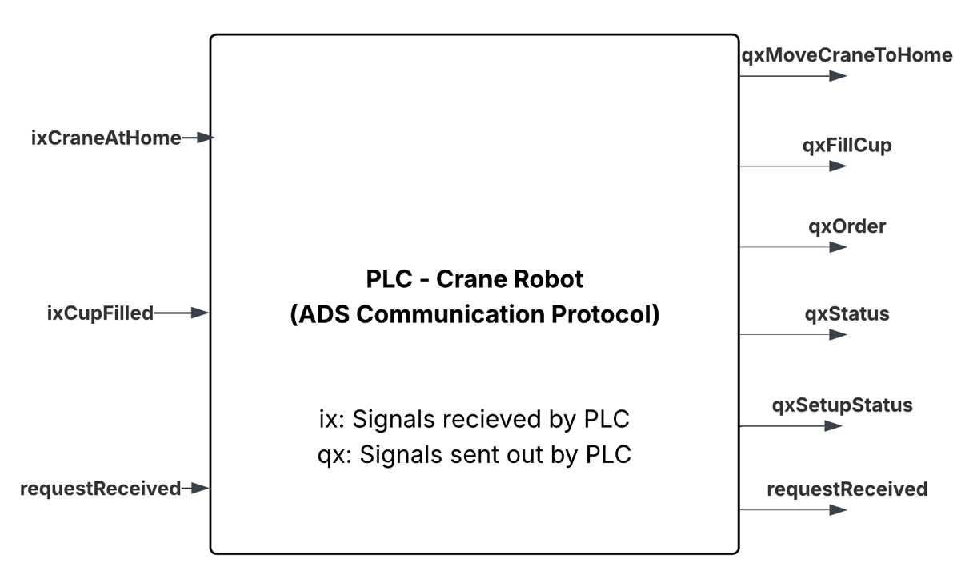

- Student Aanu Olakunle responsibility
- Designed and implemented the PLC program logic for controlling the automated coffee preparation process.
- Configured inputs, outputs, and control sequences required for process automation with TwinCAT 3.
- Developed the OPC UA server structure and configuration that enables TwinCAT 3 to communicate with other subsystems.
- Integrated the ADS functionality in TwinCAT 3, ensuring stable and efficient bidirectional communication.
- Defined and documented the communication protocol formats and message structures shared between the PLC and all connected subsystems.
- Deployed and tested the PLC program on TwinCAT PLC, ensuring correct execution and communication with connected devices.
- Collaborated with individuals handling other subsystems for system integration and end-to-end communication validation.

- Student Aanu Olakunle grading criteria

A,C and E

- Student Humble Otamiri responsibility
- Designed and implemented the PLC control logic and process flow in TwinCAT 3 according to the system requirements.
- Configured and verified the OPC UA connection setup in TwinCAT 3, ensuring proper addressing, timing, and synchronisation.
- Implemented the ADS functionality and ensure message transmission reliability between the PLC and subsystems.
- Finalise the OPC UA and ADS communication protocols, ensuring uniformity across all subsystems.
- Deployed the finalised PLC program onto TwinCAT PLC, performing validation and troubleshooting where necessary.
- Collaborated in system integration and testing with individuals responsible for SCADA, UR, Crane and AGV subsystems.
- Verified that communication and process sequences between the PLC and all subsystems perform according to design specifications.

- Student Humble Otamiri grading criteria
A,C and E

